To: Suppliers for McCain Foods North America

RE: **McCain Foods Bioterrorism and Seal Policy Compliance for Suppliers**

McCain is committed to ensuring the safety and quality of our products. As part of our ongoing safety and security initiative, McCain expects that all Suppliers comply with the requirements of the Bioterrorism Preparedness and Response Act of 2002 (“the Act”) and with McCain’s requirements regarding the sealing of all trailers.

Please review and ensure that all employees of your facility understand these mandatory.

**Inbound Full Load Shipments:**

All incoming loads shall have seals applied by the originating supplier or third party storage. The bill of lading shall state the seal number. It is the responsibility of the Carrier to verify that the trailer has been properly sealed, that the seal number on the bill of lading is accurate, and the bill of lading has been signed by the shipper. This bill of lading must accompany the shipment and be provided to receiver at time of delivery. Contents of the load and **INTACT** seals must correspond with the documentation. The trailer will be subject to possible inspection. McCain Foods reserves the right to refuse product for non-compliance of any of the above. Costs associated with the refusal shall be the responsibility of the supplier, if no seal is applied. Costs associated with the refusal shall be the responsibility of the carrier, if the signed bill of lading reflects accurate information.

**Outbound Full Load Shipments from McCain or 3rd Party Site:**

All outbound shipments shall have seals applied by the originating shipping location. The bill of lading must state the seal number. It is the responsibility of the Carrier to verify that the trailer has been properly sealed, that the seal number on the bill of lading is accurate, and that the bill of lading has been signed by the shipper. Random inspections of outgoing trucks shall be detained pending resolution by the originating shipping location and subject to possible inspection. Costs associated with improper seals or documentation shall become the originating shipping location’s responsibility, where no seal has been applied. Carrier will be responsible for costs incurred if the signed bill of lading reflects accurate information. A McCain Customer’s refusal to accept product because of discrepancies in seals or documentation is an example of this.

**Replacing Seals While Travelling To/From McCain Facilities:**

Circumstances may require that a seal be broken so that the trailer’s contents may be examined. Examples of this would be a customs inspector or a driver’s suspicion that a load may have shifted.

Customs will from time-to-time replace the seal, but **not always**. For all other situations, it shall be the responsibility of the Carrier to place the new seal. Regardless of who replaces the seal, the Carrier must ensure the documentation reflects these changes. US destined freight must be re-sealed with a bolt seal.

**LTL Inbound Shipments:**

All incoming loads shall have seals applied by the originating supplier or third party storage. The Carrier must ensure the container is sealed or padlock applied when picked up. At the first drop, the seal may be broken. Before proceeding along LTL route, trailer must either be re-sealed or a padlock applied. A seal or padlock must be in place anytime the trailer is not being loaded or unloaded. Where additional seals have been used, this shall be noted on the documentation.

If a seal or padlock is not applied, McCain Personnel reserve the right to detain or reject a trailer pending resolution by the receiving department and/or purchasing, and subject to possible inspection.

**LTL Outbound Shipments from McCain or 3rd party Sites:**

All outbound shipments must have seals applied by the originating shipping location. The Carrier must ensure the trailer is sealed when picked up. When the next pickup is added or delivery is made, the seal may be broken. A seal or padlock must be in place anytime the trailer is not being loaded or unloaded.

**Product Picked Up By Customer’s Carriers:**

Any carrier entering a McCain site or 3rd Party warehouse location may be subject to a seven (7) point trailer inspection at time of arrival at the pickup location. Inspection points shown below:

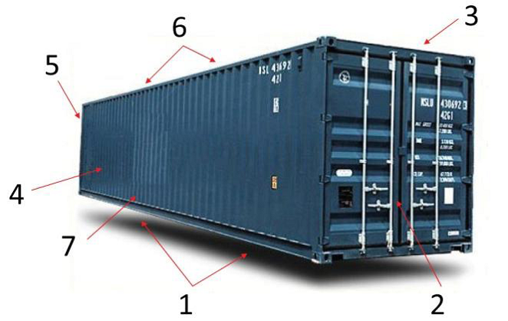

1. Undercarriage
2. Outside / Inside Doors
3. Right Side
4. Left Side
5. Front Wall
6. Ceiling / Roof
7. Floor

These procedures are ultimately about security of our food supply. McCain Foods Limited expects that all of our Carriers will take an active interest in protecting the food supply and will ensure that systems and procedures are in place to meet these requirements.

As a valued partner, McCain appreciates your cooperation in providing our customers with the assurance that our shipments are being moved on a secured trailer. Your signature of compliance on page 4 of this document confirms that your company fully understands the requirements and intends on practicing the McCain Seal Policy.

In order to comply with the Act, we are partnering with our suppliers to maintain information critical to meeting the requirements referenced in 306 of the Bioterrorism Act. This information and your signature of compliance are on page 4 of this document.

**McCain Foods Bioterrorism and Seal Policy Compliance for Suppliers**

Requirements referenced in 306 of the Bioterrorism Act:

1. Seller’s contact person for Act information requests:

Name:

Address:

Phone:

E-mail:

1. FDA/DHHS facility registration number:

1. Adherence to McCain Seal Policy
2. Shipment information recorded on “Bill of Lading”
   1. Identification of ship-from location
   2. Identification of consignee
   3. Carrier
   4. Seal number
   5. Product description including lot code information

I hereby acknowledge receipt of the McCain Foods North America Bioterrorism and Seal Policy Compliance for Suppliers. I have reviewed the document and fully understand the requirements of my organization in order to be in compliance. We fully intend on practicing these requirements and understand that non-compliance on the part of our organization will result in an investigation and possible non-compliance charges assessed by McCain.

Company Name: ______________________________

Address: ______________________________

Signature: ______________________________

Name: ______________________________

Title: ______________________________

Date: ______________________________

Telephone: ______________________________

E-mail: ______________________________